P2-iST SOP on Opentrons Flex

(36-96 samples)
This protocol is written to process up to 100 µl plasma using the Preomics P2-iST kit. All reagents are included in the P2-iST kit. This Opentrons protocol does not include the Purify section (iST cleanup) of the P2-iST protocol. Protocol name on Opentrons Flex: P2-iST

Variable Parameters
Name | Default | Range
Run Type | Sample Run | Sample Run, Water Run, Dry Run
Sample Column count  (8 samples per column) | 12 | 3-12
Multi-channel Mount | Right | Right, Left

Fixed Parameters
Name | Default
Run Type | Sample Run
Lyse, Reduction, Alkylation | Included
Incubation Temperature | 37°C
Incubation time | 1 hr
Reagent Plate type | Large 250 µL Thermo

Materials

- Opentrons Flex 96 Filter Tip Rack 200 µL (6 is the maximum, put at least X for XX samples) Deck Slots B1, B2, B3, A4, B4, C4, D4

- Opentrons Flex 96 Filter Tip Rack 50 µL Deck Slots A1, A2 (not necessary?)

- Magnetic Block Deck Slot C1

- Universal HeatShaker Adaptor (flat, rectangular) change adaptors with purple star shaped screwdriver Deck Slot D1

- Opentrons Tough 96 Well Plate 200 µL PCR Full Skirt samples (100 µL plasma) Deck Slot D1 (on heater shaker)

- Empty ThermoFisher 96 well plate 250 µL final peptides Deck Slot A3

- NEST 96 Deep Well plate 2 mL Deck Slot D4

  - Robot moved – P2 Bind Buffer Column 1
  - Robot moved – P2 Beads Column 2
  - Robot moved – Lyse mix Column 3
  - Robot moved – Stop solution Column 5

- Opentrons 24 Tube Rack Bind buffer, Beads, Lyse buffer, Digest-L, Stop buffer Deck Slot C3

- NEST 12 Well Reservoir 15 mL wash buffer Deck Slot C2

Notes
- PIPETTES LEFT: 1-channel 1000uL RIGHT: 8-channel 1000uL

- Samples up to 100µL volume in Deck Slot D1 (Opentrons Touch 96 well plate 200 µL PCR Full Skirt).

- P2 beads are placed in tube A1 (and A2 if columns>6) of Deck Slot C3. Beads should be washed before

- Solutions Lyse A and Lyse B are mixed before

PAUSE point Once the lysate-bead is incubating, set your timer to 25 min. In the last 5 minutes, prepare your trypsin solution/digestion buffer. Once complete, hit pause on the Robot and place falcon tube in Slot C3, position A3.

Make sure to double check that everything is in the correct position. Refer to layout on next page.

If labware offsets are not present, perform a labware position check with the calibration probe to ensure no crashes occur.
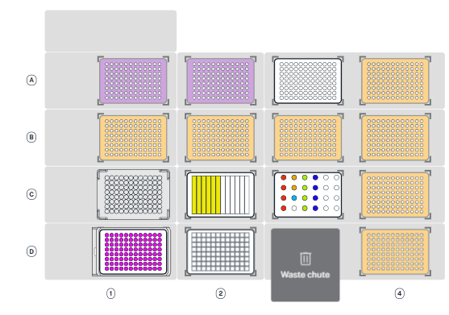
C3 - Opentrons 24 Tube Rack - 2 mL tubes
P2 Bind (2 mL tubes) 75 µl/sample, provide 75*8*COLUMNS + dead volume (25 µL per tube)
- 1.825 mL per tube for each 3 columns (or 24 samples) = 4 tubes needed for 96 samples
P2 Beads (2 mL tubes) 25 µl/sample, provide 25*8*COLUMNS + dead volume (25 µL per tube)
- 1.225 mL per tube for each 6 columns (or 48 samples) = 2 tubes needed for 96 samples
Lyse A/B mix (2 mL tube) – 40 µL/sample, provide 40*8*COLUMNS + dead volume (25 µL per tube)
- 980 mL per tube for each 3 columns (or 24 samples) = 4 tubes needed for 96 samples
  - 0.985?
Digest-L resuspended (2 mL tube) 10 µL/sample, provide 10*8*COLUMNS + 25 µL
+120? Line 180
Stop buffer (2 mL tube) – 60 µL/sample, provide 60*8*COLUMNS + dead volume (25 µL per tube)
- 1.465 mL per tube for each 3 columns (or 24 samples) = 4 tubes needed for 96 samples

C2 – NEST 12 well reservoir 15 ml
Wash Buffer 600 µL/sample, provide 600*sample#+1500 µL
- 11 mL per well for each 2 columns (or 16 samples) = 6 wells needed for 96 samples

NEST 12 Deep well plate 15 ml
Thermofisher 96 well plate 250 ul
P50 tips (filter)
P200 tips (filter)
Magnetic Block
NEST 96 Deep well plate 2 ml
Universal Heat shaker adaptor
Samples

